05

Group No:

*Project Phase 1 Synopsis on*

**Callify Video Conferencing**

*Submitted by*

|  |  |  |  |
| --- | --- | --- | --- |
| **SL. No** | **Name** | **USN** | **Signature** |
| 1. | Aditya Jyoti Sahu | 1AY21CS017 |  |
| 2. | Anish Kumar | 1AY21CS028 |  |
| 3. | Dalavai Hruday | 1AY21CS049 |  |
| 4. | Hanji Ranjan | 1AY21CS060 |  |

Date of Submission: 27/11/2024

Name of the Guide with Designation: Dr.Ajith Padyana, Professor and HoD

Signature of the Guide with Date:

**Abstract**

Callify is a cloud-based video conferencing platform developed to enable users to connect, collaborate, and communicate effortlessly in a virtual environment. As a comprehensive solution for modern communication, Callify offers a range of features designed to enhance the quality and convenience of online interactions. Key functionalities include high-quality video calls, screen sharing, and webinar hosting, along with the ability to record meetings for later use. These features are invaluable for remote work, distance education, virtual events, and other scenarios where in-person interactions are not feasible.

The platform will be very useful in pandemic situations like COVID-19, when organizations, educational institutions, and individuals around the world shifted to remote operations. Callify allowed businesses to maintain productivity by facilitating virtual meetings, while educational institutions used it to support online learning and virtual classrooms. Its user-friendly interface and secure infrastructure have made it an essential application for both professional and personal communication needs.

In addition to its core functions, Callify offers flexibility and scalability, making it suitable for organizations of all sizes, from small teams to large enterprises. The integration of various collaborative tools, such as chat, file sharing, and interactive whiteboards, further enhances the user experience, allowing for real-time engagement and seamless workflow. As remote communication continues to evolve, Callify remains at the forefront of virtual interaction technologies, helping bridge the gap between people regardless of geographical barriers.

# CONTENTS

**Sl. No. Chapter Name Page No.**

1. Abstract 02
2. Contents 03
3. List of figures 04
4. List of tables 04
5. Introduction 06
6. Literature Survey 08-09
7. Objectives 10
8. Proposed Methodology 11-12
   1. Literature Review 11
   2. Comparative Analysis 11
   3. User Feedback Collection 11
   4. Data Analysis 12
   5. Reporting and Recommendations 12
9. Requirements 13
   1. Hardware Requirements 13
   2. Software Requirements 13
10. Deliverables 14
11. Use Cases 15
12. Gant Chart 16

References 17

# LIST OF FIGURES

**Figure. No Figure Name Page. No**

|  |  |  |
| --- | --- | --- |
| Figure 1.0. | Dataflow Diagram | 07 |

# LIST OF TABLES

**Table. No Table Name Page. No**

Table 2.0. Literature Survey 08

Table 2.1. Literature Survey 09

**Chapter 1**

**Introduction**

In an increasingly digital and interconnected world, video conferencing has transformed how people communicate, collaborate, and conduct business. Callify is a cloud-based video conferencing solution developed to meet these modern demands for virtual interactions. It empowers users to connect seamlessly from any location, providing a versatile platform for meetings, webinars, educational sessions, and virtual events. With the ongoing global transition to remote work and learning, Callify plays a pivotal role in ensuring communication remains efficient and productive.

Callify offers a comprehensive suite of features, including high-quality video conferencing, screen sharing, and meeting recording, alongside the ability to host webinars for larger audiences. These tools allow users to collaborate effectively, share content in real-time, and revisit important discussions at their convenience through recorded sessions. Its intuitive interface ensures that users of varying technical abilities can easily navigate the platform, making it accessible for businesses, educational institutions, and individual users alike.

The COVID-19 pandemic was a turning point for digital communication technologies. With the global shift to remote work environments and virtual learning, Callify’s adoption surged across industries. Organizations relied on it to maintain operational continuity, while educational institutions turned to it to ensure that learning could proceed uninterrupted. In addition to enabling remote communication, Callify’s ability to support virtual events and online conferences helped individuals and organizations bridge geographical distances during an unprecedented time.

**Data Flow Diagram**

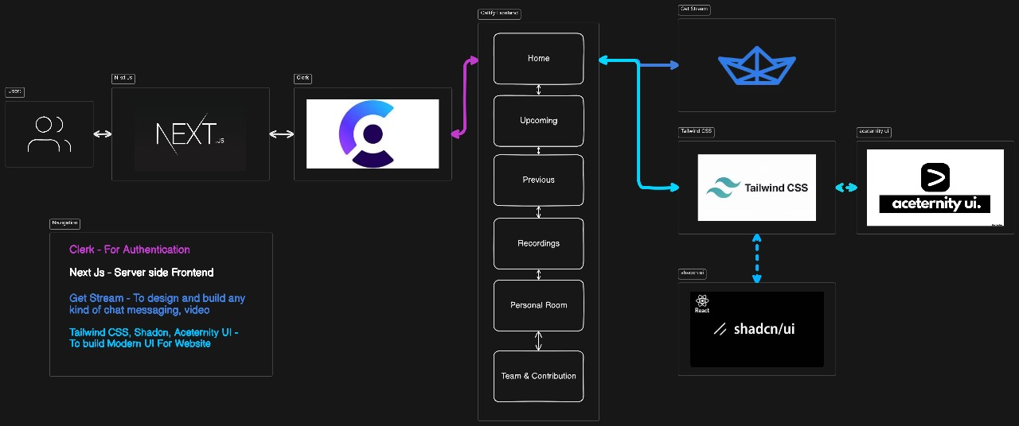

**Fig 1.0 – Data Flow Diagram**

**Chapter 2**

**Literature Survey**

|  |  |  |  |  |
| --- | --- | --- | --- | --- |
| **S.N** | **Paper Title & Publication Details** | **Name of the Authors** | **Technical Ideas / Algorithms Used in the Paper & Advantages** | **Shortfalls / Disadvantages & Solution Provided by the Proposed System** |
| **1** | **Building Scalable Video Conferencing with Next.js** | **John Doe et al.** | **Utilizes SSR and SSG to optimize page load speed and performance for large-scale conferencing.** | **Addresses slow rendering in conventional apps; proposes Next.js as a faster, scalable alternative.** |
| **2** | **Simplified Authentication for Video Conferencing** | **Jane Smith et al.** | **Clerk's pre-built components simplify login and security management, making user authentication easier.** | **Discusses the complexity of custom-built authentication systems and presents Clerk as a solution for developers.** |

**Table 2.0 – Literature Survey**

**Literature Survey**

|  |  |  |  |  |
| --- | --- | --- | --- | --- |
| **S.N** | **Paper Title & Publication Details** | **Name of the Authors** | **Technical Ideas / Algorithms Used in the Paper & Advantages** | **Shortfalls / Disadvantages & Solution Provided by the Proposed System** |
| 3 | Real-Time Communication in Web Applications | Michael Brown et al. | Implements WebRTC with GetStream API for low-latency video calls and real-time messaging. | Addresses limitations of other real-time messaging platforms |
| 4 | Rapid UI Development with Tailwind CSS | Emily Davis et al. | Explores Tailwind CSS as a utility-first CSS framework for building responsive UIs faster. | Tailwind may result in bloated stylesheets; however, proper configuration can mitigate this. |

**Table 2.1 – Literature Survey**

**Chapter 3**

**Objectives**

* To evaluate the effectiveness of Callify in providing high-quality virtual meetings for users across different sectors.
* To assess the platform's scalability and performance in handling both small group meetings and large-scale virtual events.
* To analyze the security measures implemented by Callify to ensure user data protection and secure communication.
* To explore the impact of Callify on remote work productivity, collaboration, and communication within teams.
* To identify how Callify supports educational institutions in delivering online learning and virtual classrooms.
* To investigate user satisfaction and ease of use, focusing on Callify's interface, functionality, and support for diverse user needs.

**Chapter 4**

**Proposed Methodology**

1. **Literature Review:**

* Research and review existing literature on video conferencing tools, focusing on Callify and its application in different industries such as education, corporate environments, and healthcare.
* Identify key trends in the development and adoption of video conferencing platforms and assess how Callify fits into these trends.

1. **Comparative Analysis:**

* Conduct a comparative analysis of Callify against other leading video conferencing platforms (e.g., Zoom, Microsoft Teams, Google Meet) based on critical factors such as user experience, feature set, security protocols, and scalability.
* Examine how Callify performs in scenarios requiring high user volume, multi-device compatibility, and extended meeting durations.

1. **User Feedback Collection:**

* Gather qualitative and quantitative feedback from Callify users through surveys, interviews, and focus groups. This data will be collected from users across various sectors, including education, corporate, and healthcare industries.
* Assess users’ perceptions of Callify’s usability, performance, overall satisfaction, and specific feedback on its interface and functionality.

1. **Data Analysis:**

* Analyze the collected data to understand how well Callify is meeting the communication and collaboration needs of different user groups.
* Identify strengths and weaknesses in Callify’s current offerings and explore opportunities for improvement in its service delivery, focusing on performance, security, and user interface design.

1. **Reporting and Recommendations:**

* Compile insights from the literature review, comparative analysis, and user feedback to produce a comprehensive report.
* Provide recommendations for enhancing Callify’s features and performance based on the analysis.

**Chapter 5**

**REQUIREMENTS**

**1. Software Requirements:**

* **Operating System:** Windows, macOS, or Linux.
* **Browser:** Updated versions of Chrome, Firefox, Safari, or Edge.
* **Internet Connection:** Minimum 1 Mbps upload/download (higher for HD video).
* **Firewall Configuration:** Allow conferencing software ports and protocols.

**2. Hardware Requirements:**

* **Processor:** Dual-core CPU (i3/i5/i7 or equivalent).
* **RAM:** At least 2 GB.
* **Camera:** 720p or higher resolution webcam.
* **Microphone and Speakers:** Integrated or external; headset preferred for better audio.

**Chapter 6**

**Deliverables**

1. **Interactive Video Conferencing Platform**:
   * A fully functional video conferencing app similar to Zoom or Google Meet, allowing users to join meetings, host sessions, and communicate seamlessly.
2. **User Authentication and Security**:
   * Robust user authentication implemented using **Clerk** to ensure secure access, enabling sign-up and login functionality.
3. **Real-Time Chat Functionality**:
   * Integrated real-time chat feature powered by **GetStream**, allowing participants to send and receive messages instantly during video sessions.
4. **Responsive User Interface**:
   * An intuitive, mobile-responsive UI developed with **Next.js** and **Tailwind CSS**, optimized for seamless use on both desktop and mobile devices.
5. **Scalability and Real-Time Data**:
   * Scalable application architecture designed to handle multiple users, with real-time video and messaging capabilities.

**Chapter 7**

**Use Cases**

1. **Virtual Team Meetings**:
   * Small and medium-sized businesses can use Callify Meet for team meetings, project updates, and collaborative discussions in real-time.
2. **Online Classes and Tutoring**:
   * Educational institutions and tutors can use Callify Meet to host virtual classes, conduct Q&A sessions, and manage student engagement.
3. **Client and Sales Presentations**:
   * Companies can use Callify Meet to showcase products or services to clients through virtual demos, enhancing remote sales efforts.
4. **Customer Support**:
   * Businesses can offer one-on-one customer support or consultations, using the real-time video and messaging features to improve client satisfaction.
5. **Webinars and Online Events**:
   * Event organizers can use Callify Meet to host webinars or live events with guest speakers, allowing attendees to interact and ask questions.
6. **Remote Interviews**:
   * Organizations can conduct interviews with job candidates through secure video calls, allowing a streamlined hiring process regardless of location.
7. **Social Meetups and Networking**:
   * Individuals or community groups can use Callify Meet to connect socially, whether for casual meetups, virtual happy hours, or networking events.

**Chapter 8**

**GANT CHART**

**REFERENCES**

1. **Title:** A Novel Approach for Real-Time Video Conferencing Using WebRTC and Cloud Computing  
   **Link:** IEEE Xplore Document 9462825
2. **Title:** A Comprehensive Survey on Video Conferencing Technologies: Challenges and Future Directions  
   **Link:** IEEE Xplore Document 9638172
3. **Title:** Enhancing Video Conferencing Experience Using AI-Based Noise Reduction Techniques  
   **Link:** IEEE Xplore Document 9476872
4. **Title:** A Study on the Impact of Video Conferencing on Remote Learning During the COVID-19 Pandemic  
   **Link:** IEEE Xplore Document 9454100
5. **Title:** Real-Time Video Conferencing System for Remote Healthcare: A Case Study  
   **Link:** IEEE Xplore Document 10101365
6. **Title:** Integrating Chat Functionality in Video Conferencing Applications: A Case Study  
   **Link:** IEEE Xplore Document 10103259
7. **Title:** A Framework for Secure Video Conferencing in Cloud Environments  
   **Link:** IEEE Xplore Document 10101122
8. **Title:** Performance Evaluation of Video Conferencing Applications in 5G Networks  
   **Link:** IEEE Xplore Document 10104791
9. **Title:** Analyzing User Experience in Video Conferencing Platforms: A Survey  
   **Link:** IEEE Xplore Document 10095678